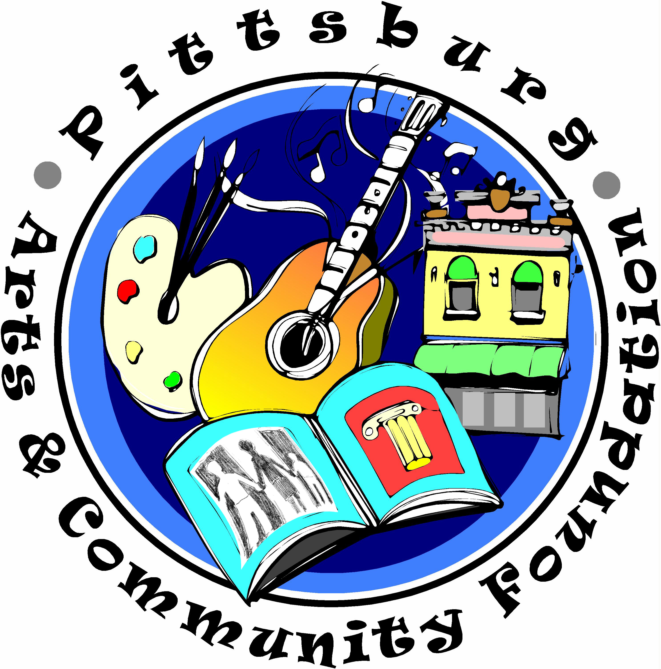

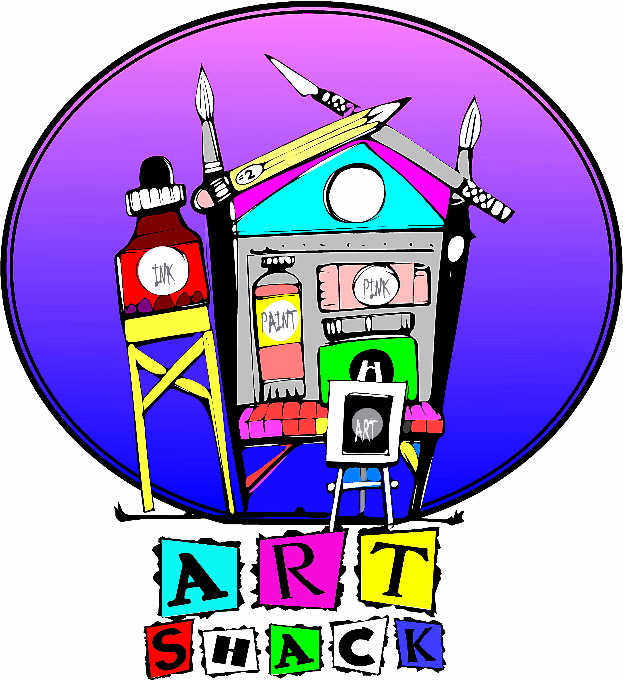
No Fee Art Classes for all public, private and Home School students. Adults are welcome for a nominal fee of $25.00 per month.
All classes are held at the Art Shack located at 31 Marina Blvd., Pittsburg, California.

Enrollment Info: Contact Rose Mary Tumbaga at (925) 252-6930

Painting and Drawing Studio: Students of all levels of expertise gather in this studio to work on their projects together, in their preferred media, i.e. Oil/Acrylic/Watercolor/Mixed Media/Pastel & other forms of dry media. A fine Arts instructor is present to provide individual instruction and critiques as well as monthly demonstrations on requested topics. (Oil Painters—Please use odorless solvents.) Instructor: Karen Nelson Kelly

- 9:30 – 11:30 a.m., Wednesdays, (Home School Students Ages 14 and up)
- March 4 –June 10 2015, Adult Student Fee: $25.00 per month.

Beginning/Intermediate Drawing: This class is suitable for beginners as well as students who already paint but would like to improve their drawing skills. We will Study basic drawing methods, including depiction of light & value, shape/form, line, textures, proportion and perspective in a variety of dry media. Additional challenges will be offered to the established painters. (Materials lists will be available upon enrollment.) Instructor: Karen Nelson Kelly

- 12:30 – 2:30 p.m., Wednesdays, (Home School Students Ages 14 and up)
- March 4 –June 10 2015, Adult Student Fee: $25.00 per month.

Beginning/Intermediate Watercolor: Learn The Pure and simple techniques of watercolor. Demonstrations and or group projects at each class on using watercolor transparently, layered, textures, and more. Individual instruction and group critiques will be conducted. (Materials list will be available upon enrollment.) Instructor: Karen Nelson Kelly

- 9:30 to 11:30 am Thursdays, (Home School Students Ages 14 and up)
- March 4 –June 10 2015, Adult Student Fee: $25.00 per month.

Oil or Acrylic Painting: Learn to create strong compositions and attain accurate color, values and representations through demonstration and individual instruction. Acquire a greater visual awareness and still to interpret and develop your painting abilities in a representational manner. Oil/Acrylic media from photos or still life setups. (Materials list will be available upon enrollment.) Instructor: Karen Nelson Kelly

- 12:30 to 2:30 pm Fridays, (Home School Students Ages 14 and up)
- March 4 –June 10 2015, Adult Student Fee: $25.00 per month.

(Disclaimer: This program is not sponsored by the Pittsburg Unified School District and any relative opinions are not necessarily those of the school district or district personnel.)

Sculpey Clay: This class explores sculpture with Non-toxic clay that does not require a kiln. This polymer clay comes in a variety of colors and therefore, no glazing is required either. Once sculptures are completed they can be baked in a regular oven, giving a ceramic-like finish. Projects include whimsical creatures, free form sculptures and bead making. Supplies are included. Instructor: Karen Nelson Kelly

- 9:30 to 11:30 am Fridays, (Home School Students Ages 8 yrs. & up)
- March 4 –June 10 2015

Teen Mural Internship Program: Interested in Drawing & Painting? Open to dedicated high school students living in Pittsburg. Be a part of the Teen Mural Internship Program and learn to strengthen yours artistic and community skills! Work alongside professional muralists for a nine week internship. Contribute to Pittsburg’s renaissance by collaborating with communities to create public works of Art. .Supplies are included. Instructor: Francis Palermo

- 3:30 to 5:30 pm Mondays and Tuesdays, NO FEE. (High School Students Age 14 yrs. & up)
- April 20 – June 9, 2015

After School Arts and Crafts: This class will offer elementary school age children the opportunity turn recycled green materials and other age appropriate supplies into creative and fun arts and craft projects. Supplies are included. Instructor: Laurie Johnson

- 3:00 to 4:30 pm Wednesdays, Thursdays, and Fridays, NO FEE (Elementary and Home School Students Ages 7 yrs. & up)
- April 20 – June 9, 2015

(Disclaimer: This program is not sponsored by the Pittsburg Unified School District and any relative opinions are not necessarily those of the school district or district personnel.)

